**AI-Driven Medical Fundraising Verification System to Detect and Prevent Fraudulent Treatment Requests**

**Abstract**

Medical Fund refers to financial assistance provided to individuals or families in need of support for medical treatments, surgeries, or emergencies. Such initiatives often rely on crowdfunding platforms, social media campaigns, or charitable organizations to raise funds. However, the rise of Medical Fund Fraud has become a significant challenge, where fraudsters fabricate treatment documents or bills to solicit donations deceitfully, undermining the trust of donors and affecting genuine beneficiaries. Existing fraud detection systems are often manual or semi-automated, requiring human verification of submitted documents. These processes are time-consuming, error-prone, and struggle to identify sophisticated fraudulent attempts. The lack of comprehensive and automated mechanisms further exacerbates the issue, leading to donor skepticism and reduced willingness to contribute. This project offers an AI-driven approach to detect and block fraudulent medical fund requests. It incorporates advanced YOLOv8 for detecting text regions in uploaded treatment bills and PaddleOCR for extracting and recognizing the text. The extracted information—such as hospital names, patient details, and treatment costs—is verified against a trusted hospital dataset using the Fuzzy Matching Algorithm, which measures the similarity between extracted text and stored records to identify discrepancies effectively. By automating text detection, recognition, and pattern matching, this system ensures accurate verification of medical fund requests, safeguarding donor contributions and fostering trust in medical crowdfunding efforts.

Top of Form

**TABLE OF CONTENTS**

|  |  |  |
| --- | --- | --- |
| **C. NO** | **TITLE** | **PAGE NO** |
|  | **ABSTRACT** |  |
| **1** | **INTRODUCTION** |  |
|  | 1.1. Overview |  |
|  | 1.2. Problem Statement |  |
|  | 1.3. Deep Learning |  |
|  | 1.4. Aim and Objective |  |
|  | 1.5. Scope of the Project |  |
| **2** | **SYSTEM ANALYSIS** |  |
|  | 2.1. Existing System |  |
|  | 2.1.1. Disadvantage |  |
|  | 2.2. Proposed System |  |
|  | 2.2.1. Advantages |  |
| **3.** | **SYSTEM CONFIGURATION** |  |
|  | 3.1. Hardware Specification |  |
|  | 3.2. Software Specification |  |
|  | 3.3. Software Description |  |
| **4** | **SYSTEM DESIGN** |  |
|  | 4.1. System Architecture |  |
|  | 4.2. Data Flow Diagram |  |
|  | 4.3. UML Diagram |  |
|  | 4.4. ER Diagram |  |
|  | 4.5. Database Design |  |
| **5.** | **MODULES DESCRIPTION** |  |
|  | 5.1. Project Description |  |
|  | 5.2. Modules Description |  |
| **6** | **SYSTEM TESTING** |  |
|  | 6.1. Testing Strategies |  |
|  | 6.2. Test Cases |  |
|  | 6.3. Test Report |  |
| **7** | **APPENDIX** |  |
| **8** | **CONCLUSION** |  |
| **9** | **FUTURE ENHANCEMENT** |  |
| **10** | **REFERENCE** |  |

**CHAPTER 1**

**INTRODUCTION**

**1.1. OVERVIEW**

Medical fundraising is the process of raising financial support for individuals who need funds for medical treatments, surgeries, or ongoing healthcare expenses. It is commonly done through crowdfunding platforms, charitable organizations, NGOs, and community-driven efforts. People create campaigns, share their medical conditions, and request donations from the public, friends, family, or corporate sponsors.

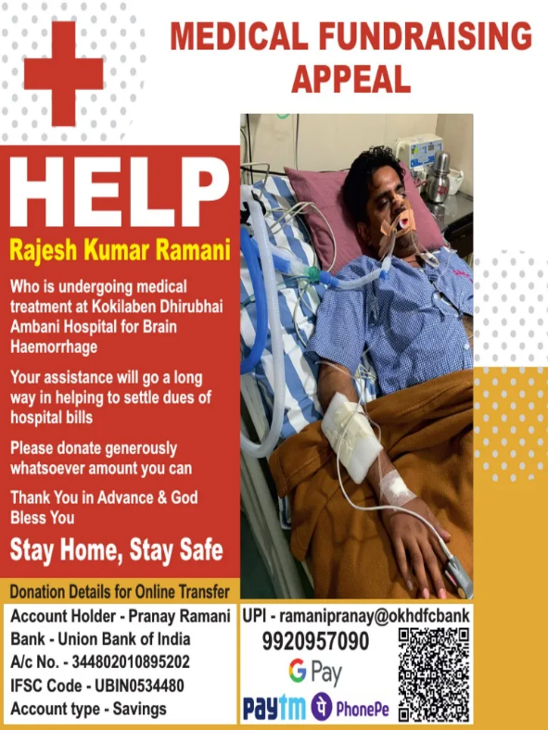

With the rise of online fundraising platforms, individuals can share their medical fund requests through social media, websites, and donation portals. However, the lack of proper verification mechanisms has led to fraudulent activities where scammers create fake medical bills to exploit donors. Hence, advanced fraud detection systems using AI and pattern-matching algorithms are essential to ensure transparency and authenticity in medical fundraising.

**1.2. PROBLEMS DEFINITION**

The growing trend of medical crowdfunding has been marred by an increase in fraudulent fund requests, where scammers manipulate or fabricate medical treatment bills to deceive potential donors. This issue not only results in financial losses for well-meaning donors but also undermines the integrity of legitimate fundraising efforts. Current systems for verifying medical treatment requests are often manual, time-consuming, and prone to errors, making it challenging to accurately detect fraudulent claims. The lack of an automated, reliable mechanism for fraud detection further exacerbates this problem, leaving donors vulnerable to exploitation. There is an urgent need for an AI-based solution that can automatically verify the authenticity of medical fund requests, detect fraudulent documents, and ensure that donations reach the deserving individuals who genuinely require financial assistance for medical treatment.

**1.3. DEEP LEARING**

Deep learning reflects a subset of machine learning and artificial intelligence. Deep learning is machine learning that draws inspiration from the human brain structure. Its algorithms tend to analyse data within a logical system continuously. This helps deep learning construct patterns that relate to the human brain essential in making conclusions and decisions.

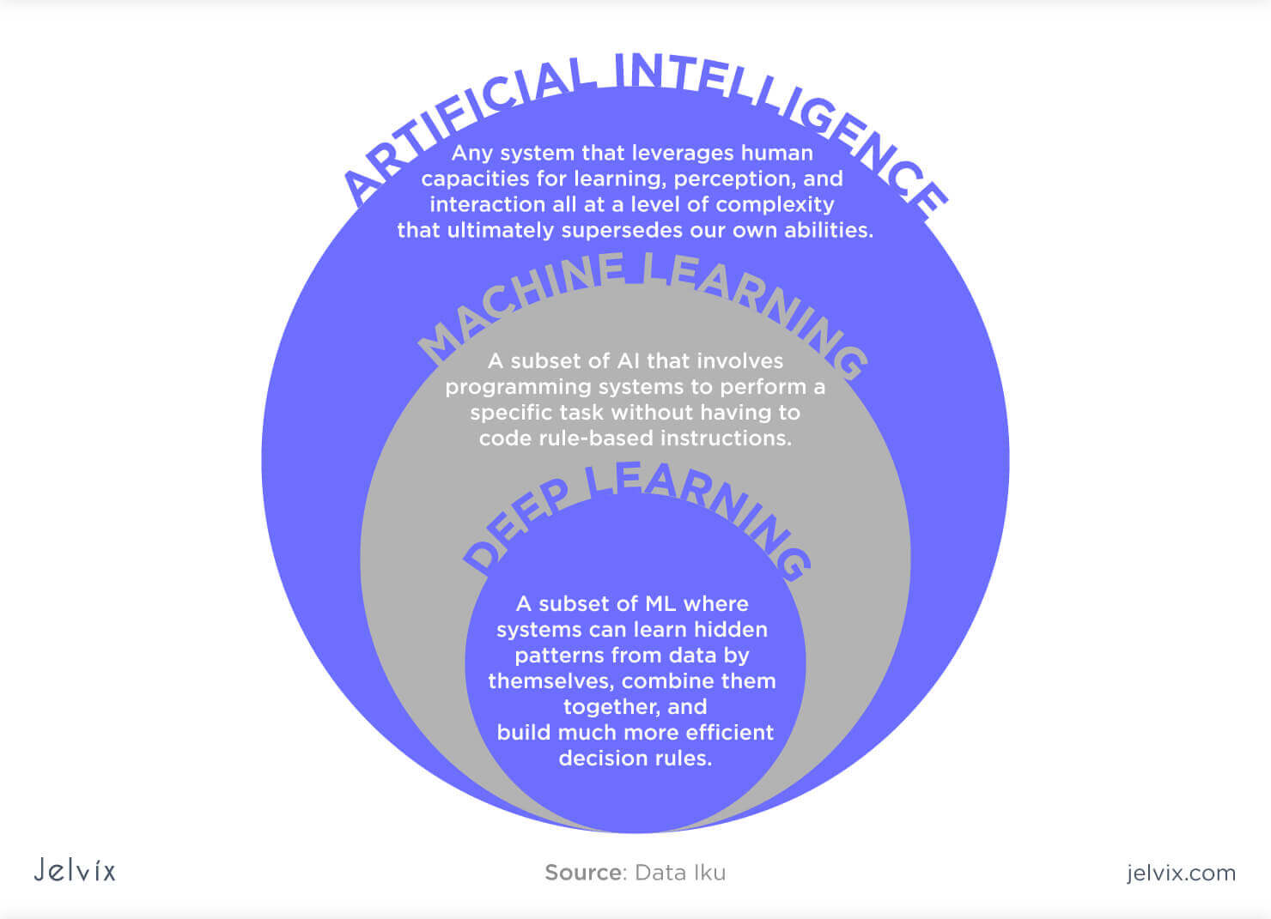

A deep learning model normally refers to a neural network, typically with more than two layers. Deep learning is usually used for computationally dense tasks like computer vision (images) and natural language processing. In technical terms, deep learning uses something called "neural networks," which are inspired by the human brain. These networks consist of layers of interconnected nodes that process information. The more layers, the "deeper" the network, allowing it to learn more complex features and perform more sophisticated tasks.

* **Handling unstructured data:** Models trained on structured data can easily learn from unstructured data, which reduces time and resources in standardizing data sets.
* **Handling large data:** Due to the introduction of graphics processing units (GPUs), deep learning models can process large amounts of data with lightning speed.
* **High Accuracy:** Deep learning models provide the most accurate results in computer visions, natural language processing (NLP), and audio processing.
* **Pattern Recognition:** Most models require machine learning engineer intervention, but deep learning models can detect all kinds of patterns automatically.

**1.3.1. YOLOv8**

YOLOv8 represents a significant milestone in computer vision, designed to enhance the efficiency and precision of object detection. Its underlying principle simplifies the process by processing an entire image through a neural network known as a convolutional neural network (CNN) in a single pass, eliminating the need for laboriously inspecting each part of the image individually. This streamlined approach, often referred to as “You Only Look Once,” leads to impressive gains in both speed and efficiency.

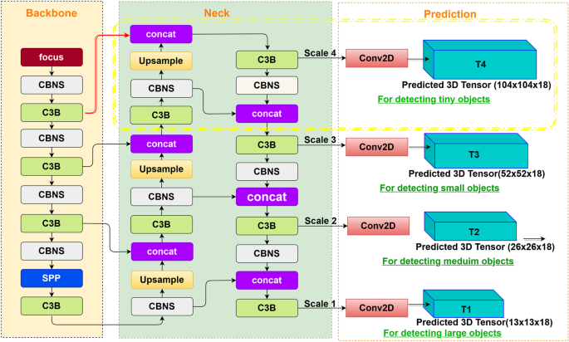

At its core, YOLOv8 follows a straightforward set of principles. It all starts with an input image, which can be of varying sizes, making it a versatile tool for a wide range of applications. The image then undergoes a process of feature extraction within a neural network. This network, carefully engineered and trained, excels at identifying and highlighting the most relevant features within the image, akin to a detective piecing together crucial clues at a crime scene. YOLOv8 stands out by not just detecting objects at a single scale but by simultaneously spotting them at different scales, ensuring it can identify objects both large and small effectively.

**Anchor-Free Detection**

YOLOv8 switched to anchor-free detection to improve generalization. The problem with anchor-based detection is that predefined anchor boxes reduce the learning speed for custom datasets. With anchor-free detection, the model directly predicts an object’s mid-point and reduces the number of bounding box predictions. This helps speed up Non-max Suppression (NMS) – a pre-processing step that discards incorrect predictions.

**1.4. AIM AND OBJECTIVE**

**Aim**

To develop an AI-powered system for detecting and preventing fraudulent medical fund requests by verifying treatment documents using advanced text detection, recognition, and pattern-matching techniques.

**Objectives**

* To automate the verification of medical fund requests using AI-based fraud detection.
* To integrate YOLOv8 for detecting text in treatment bills and PaddleOCR for text recognition.
* To apply Fuzzy Matching Algorithm to compare extracted text with authentic hospital records.
* To enhance donor trust by ensuring that only genuine medical fund requests are approved.
* To minimize fraudulent activities in medical crowdfunding by providing a reliable and efficient verification system.

**1.5. SCOPE OF THE PROJECT**

This project aims to develop a comprehensive AI-driven system for detecting fraudulent medical fund requests. The scope of the project includes:

1. **User Roles**: The system will support two main user roles—patients (requesting medical help) and donors (providing financial assistance).
2. **User Registration and Login**: Patients and donors will register and log in to the platform securely, providing necessary details for identification.
3. **Medical Request Submission**: Patients can submit medical treatment requests by uploading documents, including treatment bills and related proofs.
4. **Fraud Detection**: The system will utilize YOLOv8 for text detection in images, PaddleOCR for text recognition, and Fuzzywuzzy for comparing extracted data against verified hospital datasets to detect fraudulent requests.
5. **Request Verification**: Only verified, legitimate requests will be visible to donors, while fraudulent ones will be blocked in real-time.
6. **Donation and Payment Processing**: Donors will be able to view approved medical fund requests and contribute funds through integrated payment gateways like Razorpay.

**CHAPTER 2**

**SYSTEM ANALYSIS**

**2.1. EXISTING SYSTEM**

Traditional methods for verifying medical fund requests have relied on manual processes, third-party validation, and basic rule-based checks. While these methods have been used for years, they are slow, inefficient, and prone to errors. Fraudsters have found ways to bypass these verification steps, leading to a rise in medical fund fraud. Below are some of the commonly used traditional methods and their limitations.

* **Manual Document Verification**

In this method, hospitals, crowdfunding platforms, or donors manually review medical bills, prescriptions, and other supporting documents submitted by patients. They check for inconsistencies, formatting errors, and any signs of forgery. However, this process is highly **time-consuming**, relies on human expertise, and is prone to errors, especially with sophisticated fraudulent documents.

* **Phone or Email Verification**

Donors or fundraising platforms contact hospitals or doctors via phone or email to verify if a particular patient is undergoing treatment. While this method helps confirm details, it depends on the **responsiveness of hospitals** and can lead to delays in fund approvals. Additionally, fraudsters may provide fake contact details to deceive verifiers.

* **Third-Party Trust Networks**

Some crowdfunding platforms rely on NGOs, hospitals, or medical institutions to validate medical fund requests. These trusted third parties verify patient details before approving funds. While this method adds a layer of security, it **lacks scalability** and cannot handle a large number of requests efficiently. It also depends on the availability and cooperation of third-party organizations.

* **Pattern-Based Rule Engines**

Basic fraud detection systems use predefined rules to detect suspicious activities. For example, the system may flag requests with similar medical bills, repetitive content, or unusual donation patterns. However, fraudsters can easily **modify their tactics** to bypass these rules, making this approach **less effective against advanced forgery techniques**.

* **Community-Based Reporting**

Some platforms allow users or donors to report fraudulent medical fund requests. If multiple reports are received, the request undergoes additional verification or is removed. However, this method **relies on user awareness** and does not prevent fraud before funds are collected. Many fraudulent campaigns may go unnoticed if no one reports them in time.

**Existing Rule-Based Algorithms**

Rule-based algorithms are traditional approaches used in fraud detection systems, relying on predefined conditions to identify fraudulent activities. These methods operate on static rules that classify transactions or documents as genuine or fraudulent based on specified criteria. However, while effective in simple cases, rule-based approaches struggle with evolving fraud techniques and sophisticated forgeries. Below are some common rule-based algorithms used in fraud detection, along with their descriptions and limitations:

* **Regular Expression (Regex) Matching**

Regular Expression Matching is widely used to detect predefined patterns in medical invoices, receipts, and supporting documents. It checks for specific structures such as hospital names, patient details, and date formats.

**Example:** A rule might validate if a date follows the format DD-MM-YYYY or if a hospital name matches an approved list.

* **Keyword-Based Filtering**

This technique scans medical fund requests for specific keywords like "emergency," "ICU," "surgery," or "cancer treatment." If a request lacks these critical terms, it may be flagged as suspicious.

**Example:** A donation request for medical treatment should contain essential keywords like "hospital," "prescription," or "doctor." If these words are absent, the system raises a red flag.

* **Basic Pattern Matching**

Pattern Matching compares uploaded medical bills with a database of verified invoices to detect inconsistencies in structure, format, or content.

**Example:** If a fraudulent bill has an incorrect hospital logo, altered font styles, or mismatched invoice numbers, the system identifies the discrepancies.

**2.1.1. Disadvantages**

* Time-consuming manual verification delays fund approvals
* Prone to human errors, allowing fraudulent documents to go undetected
* Inefficient for handling large volumes of fund requests
* Easily exploitable as fraudsters manipulate documents to bypass verification
* Delayed fund disbursement causes hardship for genuine patients
* Rigid and static system unable to adapt to evolving fraud techniques
* High error rate leading to false positives and false negatives
* Simple modifications can bypass detection mechanisms
* Requires frequent manual updates, limiting scalability
* Struggles with complex data like images and handwritten documents

**2.2. PROPOSED SYSTEM**

The proposed system aims to enhance the detection and prevention of fraudulent medical fund requests by integrating AI-driven technologies. It automates the verification process, ensuring accuracy and efficiency while minimizing human intervention.

* **AI-Based Fraud Detection**

The system employs YOLOv8 for detecting text regions in medical bills and PaddleOCR for extracting textual information such as hospital names, patient details, and treatment costs. These extracted details are then analyzed to identify potential discrepancies.

* **Pattern Matching for Verification**

To ensure authenticity, the system utilizes the Fuzzy Matching Algorithm, which compares extracted text with a trusted hospital dataset. This method effectively measures similarity and detects inconsistencies in treatment details, preventing fraudulent fund requests.

* **Automated Document Processing**

Unlike traditional manual verification methods, the proposed system automates document processing, significantly reducing the time required for fraud detection. It eliminates human errors and ensures consistency in identifying fake medical fund requests.

* **Secure and Transparent Donation Process**

The system enhances donor confidence by providing a transparent verification process. Only verified medical fund requests are displayed to potential donors, ensuring that contributions reach genuine beneficiaries.

**2.2.1. Advantages**

* Effectively identifies and blocks fake medical fund requests using AI-driven verification
* Eliminates manual document checking, reducing errors and improving efficiency
* Ensures transparency, encouraging more donors to contribute without fear of fraud
* Quickly analyzes and verifies medical bills, preventing fraudulent requests instantly
* Protects both donors and genuine beneficiaries by verifying fund requests before approval
* Can be expanded to support multiple hospitals, crowdfunding platforms, and NGOs
* Reduces the need for manual fraud detection teams, saving operational costs
* Simplifies the donation and verification process for both patients and donors

**CHAPTER 3**

**SYSTEM SPECIFICATION**

**3.1. HARDWARE SPECIFICATIONS**

* **Processor :** Intel Core i3 or higher
* **RAM :** 4GB or more
* **Storage :** 100GB available disk space
* **Internet :** Stable connection for cloud hosting and data processing

**3.2. SOFTWARE SPECIFICATIONS**

* **Operating System :** Windows 10/11
* **Programming :** Python 3.x, JavaScript, HTML5, CSS3
* **Frameworks :** Flask
* **Libraries :** PaddleOCR, YOLOv8, FuzzyWuzzy
* **Image Processing :** OpenCV, NumPy, Pandas
* **Payment Gateway :** Razorpay API
* **Database :** MySQL
* **Web Server :** WampServer

**3.3. SOFTWARE DESCRIPTION**

**3.3.1. PYTHON 3.7.4**

Python is a general-purpose interpreted, interactive, object-oriented, and high-level programming language. It was created by Guido van Rossum during 1985- 1990. Like Perl, Python source code is also available under the GNU General Public License (GPL). This tutorial gives enough understanding on Python programming language.

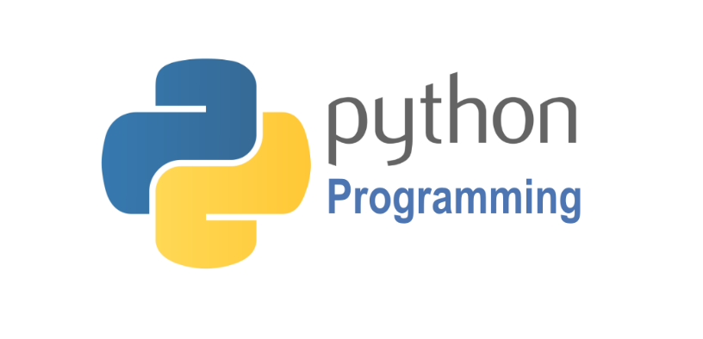

Python is a high-level, interpreted, interactive and object-oriented scripting language. Python is designed to be highly readable. It uses English keywords frequently where as other languages use punctuation, and it has fewer syntactical constructions than other languages. Python is a MUST for students and working professionals to become a great Software Engineer specially when they are working in Web Development Domain.

Python is currently the most widely used multi-purpose, high-level programming language. Python allows programming in Object-Oriented and Procedural paradigms. Python programs generally are smaller than other programming languages like Java. Programmers have to type relatively less and indentation requirement of the language, makes them readable all the time. Python language is being used by almost all tech-giant companies like – Google, Amazon, Facebook, Instagram, Dropbox, Uber… etc. The biggest strength of Python is huge collection of standard libraries which can be used for the following:

* Machine Learning
* GUI Applications (like Kivy, Tkinter, PyQt etc.)
* Web frameworks like Django (used by YouTube, Instagram, Dropbox)
* Image processing (like OpenCV, Pillow)
* Web scraping (like Scrapy, BeautifulSoup, Selenium)
* Test frameworks
* Multimedia
* Scientific computing
* Text processing and many more.

**Tensor Flow**

Tensor Flow is an end-to-end open-source platform for machine learning. It has a comprehensive, flexible ecosystem of tools, libraries, and community resources that lets researchers push the state-of-the-art in ML, and gives developers the ability to easily build and deploy ML-powered applications.

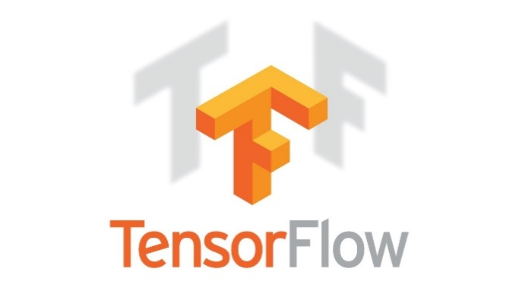

Tensor Flow provides a collection of workflows with intuitive, high-level APIs for both beginners and experts to create machine learning models in numerous languages. Developers have the option to deploy models on a number of platforms such as on servers, in the cloud, on mobile and edge devices, in browsers, and on many other JavaScript platforms. This enables developers to go from model building and training to deployment much more easily.

**Keras**

Keras is a deep learning API written in Python, running on top of the machine learning platform Tensor Flow. It was developed with a focus on enabling fast experimentation.



* Allows the same code to run on CPU or on GPU, seamlessly.
* User-friendly API which makes it easy to quickly prototype deep learning models.
* Built-in support for convolutional networks (for computer vision), recurrent networks (for sequence processing), and any combination of both.
* Supports arbitrary network architectures: multi-input or multi-output models, layer sharing, model sharing, etc. This means that Keras is appropriate for building essentially any deep learning model, from a memory network to a neural Turing machine.

**Pandas**

pandas are a fast, powerful, flexible and easy to use open source data analysis and manipulation tool, built on top of the Python programming language. pandas are a Python package that provides fast, flexible, and expressive data structures designed to make working with "relational" or "labeled" data both easy and intuitive. It aims to be the fundamental high-level building block for doing practical, real world data analysis in Python.



Pandas is mainly used for data analysis and associated manipulation of tabular data in Data frames. Pandas allows importing data from various file formats such as comma-separated values, JSON, Parquet, SQL database tables or queries, and Microsoft Excel. Pandas allows various data manipulation operations such as merging, reshaping, selecting, as well as data cleaning, and data wrangling features. The development of pandas introduced into Python many comparable features of working with Data frames that were established in the R programming language. The panda’s library is built upon another library NumPy, which is oriented to efficiently working with arrays instead of the features of working on Data frames.

**NumPy**

NumPy, which stands for Numerical Python, is a library consisting of multidimensional array objects and a collection of routines for processing those arrays. Using NumPy, mathematical and logical operations on arrays can be performed.



NumPy is a general-purpose array-processing package. It provides a high-performance multidimensional array object, and tools for working with these arrays.

**Matplotlib**

Matplotlib is a comprehensive library for creating static, animated, and interactive visualizations in Python. Matplotlib makes easy things easy and hard things possible.



Matplotlib is a plotting library for the Python programming language and its numerical mathematics extension NumPy. It provides an object-oriented API for embedding plots into applications using general-purpose GUI toolkits like Tkinter, wxPython, Qt, or GTK.

**Scikit Learn**

scikit-learn is a Python module for machine learning built on top of SciPy and is distributed under the 3-Clause BSD license.



Scikit-learn (formerly scikits. learn and also known as sklearn) is a free software machine learning library for the Python programming language. It features various classification, regression and clustering algorithms including support-vector machines, random forests, gradient boosting, k-means and DBSCAN, and is designed to interoperate with the Python numerical and scientific libraries NumPy and SciPy.

**Pillow**

Pillow is the friendly PIL fork by Alex Clark and Contributors. PIL is the Python Imaging Library by Fredrik Lundh and Contributors.



Python pillow library is used to image class within it to show the image. The image modules that belong to the pillow package have a few inbuilt functions such as load images or create new images, etc.

**OpenCV**

OpenCV is an open-source library for the computer vision. It provides the facility to the machine to recognize the faces or objects.



In OpenCV, the CV is an abbreviation form of a computer vision, which is defined as a field of study that helps computers to understand the content of the digital images such as photographs and video.

**3.3.2. MySQL**

MySQL is a relational database management system based on the Structured Query Language, which is the popular language for accessing and managing the records in the database. MySQL is open-source and free software under the GNU license. It is supported by Oracle Company. MySQL database that provides for how to manage database and to manipulate data with the help of various SQL queries. These queries are: insert records, update records, delete records, select records, create tables, drop tables, etc. There are also given MySQL interview questions to help you better understand the MySQL database.



MySQL is currently the most popular database management system software used for managing the relational database. It is open-source database software, which is supported by Oracle Company. It is fast, scalable, and easy to use database management system in comparison with Microsoft SQL Server and Oracle Database. It is commonly used in conjunction with PHP scripts for creating powerful and dynamic server-side or web-based enterprise applications. It is developed, marketed, and supported by MySQL AB, a Swedish company, and written in C programming language and C++ programming language. The official pronunciation of MySQL is not the My Sequel; it is My Ess Que Ell. However, you can pronounce it in your way. Many small and big companies use MySQL. MySQL supports many Operating Systems like Windows, Linux, MacOS, etc. with C, C++, and Java languages.

**3.3.3. WAMPSERVER**

WampServer is a Windows web development environment. It allows you to create web applications with Apache2, PHP and a MySQL database. Alongside, PhpMyAdmin allows you to manage easily your database.



WAMPServer is a reliable web development software program that lets you create web apps with MYSQL database and PHP Apache2. With an intuitive interface, the application features numerous functionalities and makes it the preferred choice of developers from around the world. The software is free to use and doesn’t require a payment or subscription.

**3.3.4. BOOTSTRAP 4**

Bootstrap is a free and open-source tool collection for creating responsive websites and web applications. It is the most popular HTML, CSS, and JavaScript framework for developing responsive, mobile-first websites.



It solves many problems which we had once, one of which is the cross-browser compatibility issue. Nowadays, the websites are perfect for all the browsers (IE, Firefox, and Chrome) and for all sizes of screens (Desktop, Tablets, Phablets, and Phones). All thanks to Bootstrap developers -Mark Otto and Jacob Thornton of Twitter, though it was later declared to be an open-source project.

**Easy to use**: Anybody with just basic knowledge of HTML and CSS can start using Bootstrap

**Responsive features**: Bootstrap's responsive CSS adjusts to phones, tablets, and desktops

**Mobile-first approach**: In Bootstrap, mobile-first styles are part of the core framework

**Browser compatibility**: Bootstrap 4 is compatible with all modern browsers (Chrome, Firefox, Internet Explorer 10+, Edge, Safari, and Opera)

**3.3.5. FLASK**

[Flask](http://flask.pocoo.org/) is a web framework. This means flask provides you with tools, libraries and technologies that allow you to build a web application. This web application can be some web pages, a blog, a wiki or go as big as a web-based calendar application or a commercial website.



Flask is often referred to as a micro framework. It aims to keep the core of an application simple yet extensible. Flask does not have built-in abstraction layer for database handling, nor does it have formed a validation support. Instead, Flask supports the extensions to add such functionality to the application.  Although Flask is rather young compared to most [Python](https://quintagroup.com/services/python) frameworks, it holds a great promise and has already gained popularity among Python web developers. Let’s take a closer look into Flask, so-called “micro” framework for Python. Flask is part of the categories of the micro-framework. Micro-framework are normally framework with little to no dependencies to external libraries. This has pros and cons. Pros would be that the framework is light, there are little dependency to update and watch for security bugs, cons is that some time you will have to do more work by yourself or increase yourself the list of dependencies by adding plugins.

**CHAPTER 4**

**SYSTEM DESIGN**

**4.1. SYSTEM ARCHITECTURE**

**AI Driven Fraud Detector**

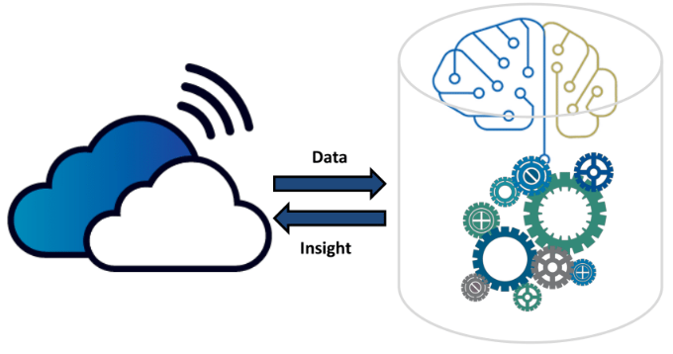

Preprocessing



Register

View Flagged Request

User management

Login

Text Recognition

Text Region Detection

Extract Upload Files Documents

**Donor**

**Admin**

**Fund Requester**

**Medical Fund Fraud Detector Web App**

View Fund Request

View Donor Responses



Login

Post Fund Request

Upload Documents

Approve/Block Req

Receive Donation

Notification



Register

Login

View Genuine Req.

Donate Payment

Notification

Hospital Database

Pattern Matching

Fund Request Verification

**4.2. DATA FLOW DIAGRAM**

**LEVEL 0**

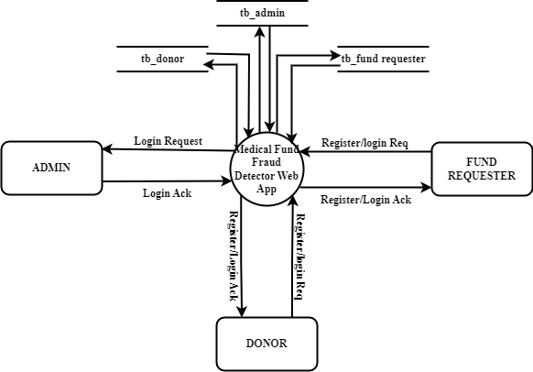

**LEVEL 1**

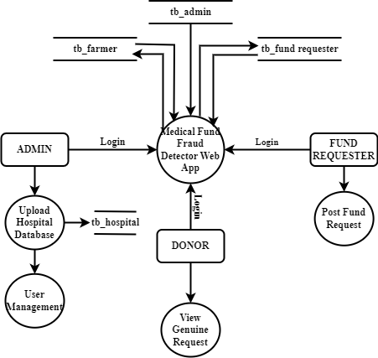

**LEVEL 2**

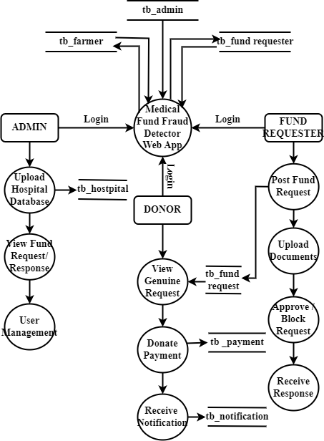

**4.3. UML DIAGRAM**

**4.3.1. USE CASE DIAGRAM**

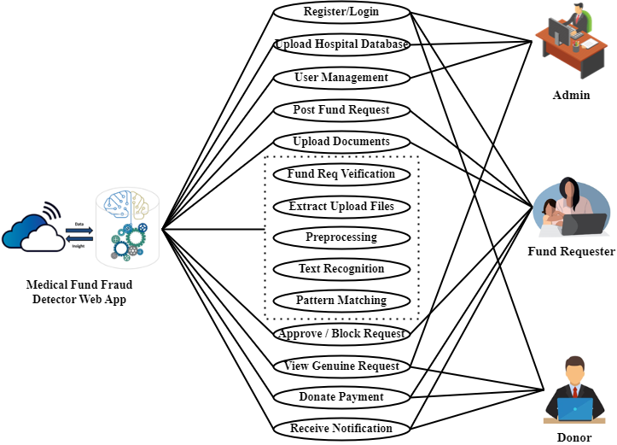

**4.3.2. CLASS DIAGRAM**

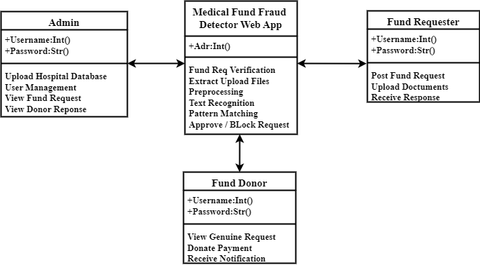

**4.3.3. SEQUENCE DIAGRAM**

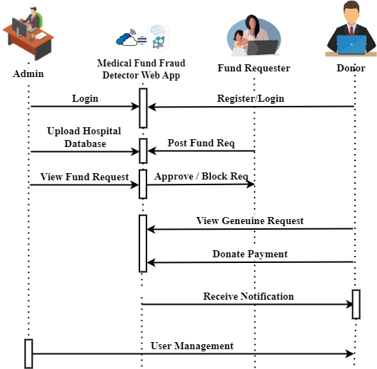

**4.3.4. ACTIVITY DIAGRAM**

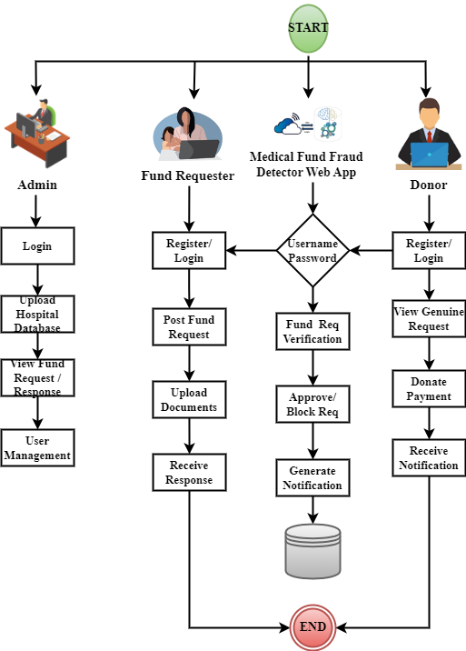

**4.3.5. COLLABORATE DIAGRAM**

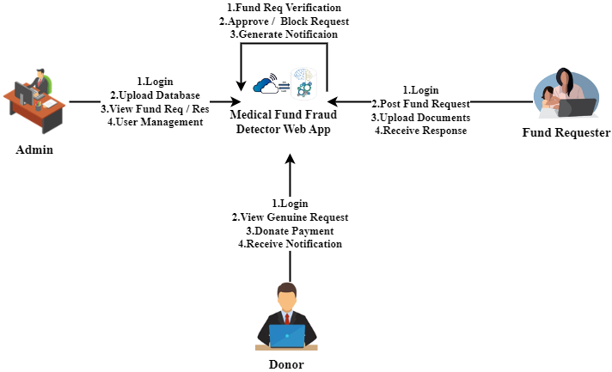

**4.3.6. COMPONENT DIAGRAM**

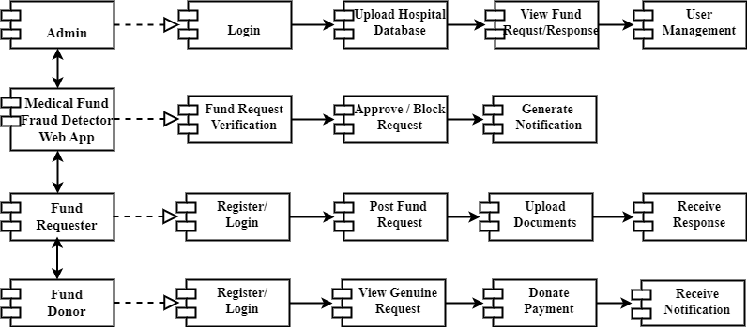

**4.4. ER DIAGRAM**

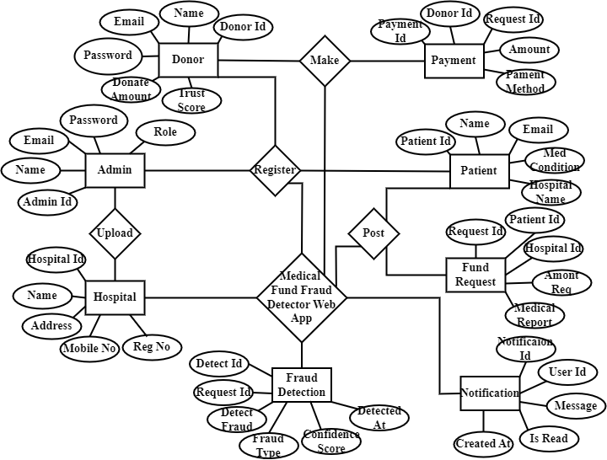

**4.5. DATABASE DESIGN**

**1. Admin Table**

|  |  |  |  |  |  |
| --- | --- | --- | --- | --- | --- |
| **S.No** | **Field** | **Data Type** | **Field Size** | **Constraint** | **Description** |
| 1 | Adminid | Int | - | Primary Key, Auto_Increment | Unique Id For Admin |
| 2 | Name | Varchar | 100 | Not Null | Admin's Full Name |
| 3 | Email | Varchar | 100 | Unique, Not Null | Admin's Email |
| 4 | Password | Varchar | 255 | Not Null | Encrypted Password |
| 5 | Role | Varchar | 50 | Default 'Moderator' | Admin Role (Superadmin, Moderator) |
| 6 | Createdat | Timestamp | - | Default Current_Timestamp | Account Creation Timestamp |

**2. Patient (Fund Requester) Table**

|  |  |  |  |  |  |
| --- | --- | --- | --- | --- | --- |
| **S.No** | **Field** | **Data Type** | **Field Size** | **Constraint** | **Description** |
| 1 | Patientid | Int | - | Primary Key, Auto_Increment | Unique Id For Patient |
| 2 | Fullname | Varchar | 100 | Not Null | Patient's Full Name |
| 3 | Email | Varchar | 100 | Unique, Not Null | Patient's Email |
| 4 | Phone | Varchar | 15 | Not Null | Contact Number |
| 5 | Password | Varchar | 255 | Not Null | Encrypted Password |
| 6 | Address | Text | - | Not Null | Patient's Residential Address |
| 7 | Medicalcondition | Text | - | Not Null | Patient's Medical Condition |
| 8 | Hospitalname | Varchar | 100 | Not Null | Associated Hospital |
| 9 | Createdat | Timestamp | - | Default Current_Timestamp | Account Creation Timestamp |

**3. Donor Table**

|  |  |  |  |  |  |
| --- | --- | --- | --- | --- | --- |
| **S.No** | **Field** | **Data Type** | **Field Size** | **Constraint** | **Description** |
| 1 | Donorid | Int | - | Primary Key, Auto_Increment | Unique Id For Donor |
| 2 | Fullname | Varchar | 100 | Not Null | Donor's Full Name |
| 3 | Email | Varchar | 100 | Unique, Not Null | Donor's Email |
| 4 | Phone | Varchar | 15 | Not Null | Contact Number |
| 5 | Password | Varchar | 255 | Not Null | Encrypted Password |
| 6 | Address | Text | - | Not Null | Donor's Address |
| 7 | Donationamount | Decimal | 10,2 | Default 0.00 | Total Donation Made |
| 8 | Trustscore | Float | - | Default 5.0 | Donor's Credibility Rating |
| 9 | Createdat | Timestamp | - | Default Current_Timestamp | Account Creation Timestamp |

**4. Hospital Table**

|  |  |  |  |  |  |
| --- | --- | --- | --- | --- | --- |
| **S.No** | **Field** | **Data Type** | **Field Size** | **Constraint** | **Description** |
| 1 | Hospitalid | Int | - | Primary Key, Auto_Increment | Unique Id For Hospital |
| 2 | Name | Varchar | 100 | Not Null | Hospital Name |
| 3 | Address | Text | - | Not Null | Hospital Address |
| 4 | Contactnumber | Varchar | 15 | Not Null | Hospital Contact Number |
| 5 | Email | Varchar | 100 | Unique, Not Null | Hospital's Email |
| 6 | Registrationnumber | Varchar | 50 | Unique, Not Null | Hospital Registration Id |
| 7 | Verified | Boolean | - | Default False | Verification Status |
| 8 | Createdat | Timestamp | - | Default Current_Timestamp | Record Creation Timestamp |

**5. Fundrequest Table**

|  |  |  |  |  |  |
| --- | --- | --- | --- | --- | --- |
| **S.No** | **Field** | **Data Type** | **Field Size** | **Constraint** | **Description** |
| 1 | Requestid | Int | - | Primary Key, Auto_Increment | Unique Id For Fund Request |
| 2 | Patientid | Int | - | Foreign Key References Patient(Patientid) | Associated Patient |
| 3 | Hospitalid | Int | - | Foreign Key References Hospital(Hospitalid) | Associated Hospital |
| 4 | Amountrequested | Decimal | 10,2 | Not Null | Requested Fund Amount |
| 5 | Medicalreport | Text | - | Not Null | Link To Uploaded Document |
| 6 | Status | Enum | - | Default 'Pending' | Fund Request Status |
| 7 | Createdat | Timestamp | - | Default Current_Timestamp | Request Submission Timestamp |

**6. Frauddetection Table**

|  |  |  |  |  |  |
| --- | --- | --- | --- | --- | --- |
| **S.No** | **Field** | **Data Type** | **Field Size** | **Constraint** | **Description** |
| 1 | Detectionid | Int | - | Primary Key, Auto_Increment | Unique Id For Fraud Detection |
| 2 | Requestid | Int | - | Foreign Key References Fundrequest(Requestid) | Fund Request Under Review |
| 3 | Detectedfraud | Boolean | - | Default False | Fraud Detected Status |
| 4 | Fraudtype | Text | - | Nullable | Type Of Fraud Detected |
| 5 | Confidencescore | Float | - | Not Null | Fraud Detection Accuracy Score |
| 6 | Detectedat | Timestamp | - | Default Current_Timestamp | Detection Timestamp |

**7. Payment Table**

|  |  |  |  |  |  |
| --- | --- | --- | --- | --- | --- |
| **S.No** | **Field** | **Data Type** | **Field Size** | **Constraint** | **Description** |
| 1 | Paymentid | Int | - | Primary Key, Auto_Increment | Unique Id For Payment |
| 2 | Donorid | Int | - | Foreign Key References Donor(Donorid) | Donor Making Payment |
| 3 | Requestid | Int | - | Foreign Key References Fundrequest(Requestid) | Fund Request Associated |
| 4 | Amount | Decimal | 10,2 | Not Null | Donation Amount |
| 5 | Paymentmethod | Varchar | 50 | Not Null | Payment Mode (Credit Card, Upi) |
| 6 | Transactionstatus | Enum | - | Default 'Pending' | Status Of Transaction |
| 7 | Createdat | Timestamp | - | Default Current_Timestamp | Transaction Timestamp |

**8. Notification Table**

|  |  |  |  |  |  |
| --- | --- | --- | --- | --- | --- |
| **S.No** | **Field** | **Data Type** | **Field Size** | **Constraint** | **Description** |
| 1 | Notificationid | Int | - | Primary Key, Auto_Increment | Unique Notification Id |
| 2 | Userid | Int | - | Not Null | Recipient Id (Admin, Donor, Patient) |
| 3 | Message | Text | - | Not Null | Notification Content |
| 4 | Isread | Boolean | - | Default False | Read/Unread Status |
| 5 | Createdat | Timestamp | - | Default Current_Timestamp | Notification Timestamp |

**Top of Form**

**CHAPTER 5**

**MODULES DESCRIPTION**

**5.1. PROJECT DESCRIPTION**

The Medical Fund Fraud Detection System is designed to ensure transparency and security in medical fund requests by detecting fraudulent activities. This project leverages advanced technologies, including Python, Flask, MySQL, Wampserver, TensorFlow, Pandas, Scikit-Learn, Matplotlib, NumPy, Seaborn, Pillow, OpenCV, and Bootstrap, to analyze and verify fund requests. The system allows patients to submit medical fund requests, donors to contribute securely, and administrators to monitor and review transactions. A core component of this system is the fraud detection module, which utilizes YOLOv8 for text region detection and OCR for text recognition to analyze uploaded medical documents. The extracted data is cross-verified with a hospital database to identify inconsistencies using pattern-matching techniques and fuzzy logic algorithms. Requests are classified as valid, suspicious, or fraudulent, ensuring only genuine cases receive donations. Additionally, the system integrates a secure payment gateway, real-time notifications, and an admin review feature for flagged requests. This approach minimizes fraudulent transactions, enhances trust between donors and recipients, and streamlines the medical funding process with automated verification and real-time fraud detection.

**5.2. MODULES DESCRIPTION**

**1. Medical Fund Fraud Detector Web App**

The Medical Fund Fraud Detection System is developed to ensure transparency and authenticity in medical fund requests by leveraging Artificial Intelligence (AI), Machine Learning (ML), and Deep Learning techniques. This project is built using Python, Flask, MySQL, WampServer, TensorFlow, Pandas, Scikit-Learn, Matplotlib, NumPy, Seaborn, Pillow, OpenCV, and Bootstrap, making it a robust web-based application. The system integrates fraud detection models with document verification to identify and prevent fraudulent medical fund requests. Flask serves as the backend framework, handling requests, authentication, and communication with the database. MySQL is used to store user information, fund request details, and fraud verification results, while WampServer provides a local environment for testing and database management. TensorFlow, Scikit-Learn, and OpenCV power the fraud detection system by processing medical documents and identifying manipulated elements such as forged signatures, tampered invoices, and duplicate requests. The YOLOv8 object detection model plays a crucial role in detecting fraud patterns in medical bills and hospital stamps. The frontend is designed using Bootstrap, ensuring a responsive and user-friendly interface. Patients can submit fund requests, upload supporting documents, and track verification results. Administrators oversee fraud detection, manage users, and train the AI model. Donors can browse verified fund requests and contribute with confidence. The project also integrates text recognition, pattern matching, and deep learning algorithms to enhance fraud detection accuracy. By combining AI-driven fraud analysis with hospital database verification, the system ensures that only genuine medical cases receive financial aid, minimizing scams and improving transparency in medical fundraising.

**2. End User**

The End User Module is designed to facilitate interaction between different stakeholders of the system, ensuring seamless and secure fund transactions while preventing fraudulent activities. It consists of three primary user roles: Admin, Patient/Fund Requester, and Fund Donor, each having distinct functionalities.

**2.1 Admin**

The Admin plays a crucial role in managing the system by overseeing fund requests, fraud detection, and user management. The Admin Dashboard allows administrators to log in securely and perform various tasks such as training the fraud detection model, adding or removing users, and verifying fund requests. The model training process involves feeding the system with datasets of fraudulent and genuine medical documents to enhance accuracy in fraud detection. Admins can review flagged fund requests that the AI system detects as potentially fraudulent and take necessary actions. Additionally, they have access to detailed fund request and response records, ensuring transparency and accountability in financial transactions.

**2.2 Patient/Fund Requester**

The Patient or Fund Requester is an individual seeking financial assistance for medical treatment. They begin by registering and logging into the system. Once authenticated, they can post a fund request by providing details about their medical condition, required treatment, and uploading relevant medical documents such as bills, prescriptions, and hospital reports. After submission, the system analyzes and verifies the request using fraud detection techniques, and the requester can view the verification results. If the request is approved and donors contribute to the cause, the patient receives payment from the donor directly, ensuring a secure and transparent process.

**2.3 Fund Donor**

The Fund Donor is an individual or organization willing to provide financial assistance to verified medical fund requests. After registering and logging in, the donor gains access to a list of genuine and verified fund requests, ensuring that their contributions go to legitimate cases. The donor can browse patient requests, review supporting documents, and make an informed decision before donating securely through the system. This ensures a trustworthy donation process, preventing fraudulent transactions and encouraging more donors to participate.

This module establishes a secure and transparent platform where fund requests are authenticated, and donations reach the intended recipients without manipulation or fraud.

**3. Hospital Database Integrator**

This module is designed to establish a secure and efficient connection between the system and hospital databases. Its primary function is to validate medical fund requests by cross-referencing submitted medical documents, prescriptions, and hospital bills with the respective healthcare providers' records. This module enhances the accuracy and credibility of the verification process, reducing fraudulent claims. The integration process begins by fetching hospital data from authorized healthcare institutions, including details such as patient records, treatment history, hospital registration, and billing information. When a patient submits a fund request, the system automatically retrieves relevant details from the linked hospital database to verify the authenticity of the provided documents. This verification includes checking hospital stamps, doctor signatures, billing authenticity, and prescribed treatments. This module supports multiple hospital databases through secure APIs, encrypted data transfer protocols, and authentication mechanisms. It also implements real-time validation, where discrepancies between submitted documents and hospital records trigger alerts for further review by the admin. Additionally, this module is designed to comply with data privacy regulations, ensuring that sensitive patient information is handled securely and only used for verification purposes.

**4. Medical Fund Request**

The Medical Fund Request module serves as the core functionality for patients seeking financial assistance for medical treatments. This module enables patients (fund requesters) to submit requests for funding by providing necessary details, including personal information, medical condition, hospital details, treatment cost, and supporting documents such as medical prescriptions, hospital bills, and test reports. Upon submission, the system processes the request through multiple verification layers. The uploaded documents undergo preprocessing, text extraction, and fraud detection mechanisms to ensure authenticity. The module integrates with the Hospital Database Integrator to cross-verify the submitted medical records with the respective hospitals, checking for duplicate requests, forged documents, and manipulated information. Each fund request is assigned a unique reference ID and categorized based on urgency, severity of the medical condition, and required treatment cost. The module also provides real-time tracking, allowing patients to view the status of their requests, whether it is under review, approved, flagged for verification, or rejected. If the request is flagged as suspicious, the system escalates it to the Admin for manual inspection. Once verified, the request is made available to registered fund donors who can review the case details and contribute financially. If a donation is made, the module ensures secure payment processing and updates the request status accordingly. This module ensures transparency, security, and efficiency, streamlining the process of receiving medical financial aid while mitigating fraudulent activities.

**5. Fraud Detection**

The Fraud Detection module is a critical component designed to ensure the authenticity of medical fund requests by analyzing submitted documents and identifying fraudulent activities. It employs a combination of deep learning, Optical Character Recognition (OCR), and pattern matching techniques to detect anomalies such as forged medical bills, fake hospital stamps, manipulated prescriptions, and duplicate requests. The module systematically processes uploaded documents through three key submodules:

**5.1. Text Region Detection**

This step involves identifying the areas within an uploaded document that contain textual information. Using YOLOv8, a powerful object detection model, the system scans and detects text regions in medical bills, prescriptions, and hospital documents. YOLOv8 is trained to recognize specific document attributes such as hospital names, patient details, payment sections, and diagnostic information. By isolating these text regions, the system ensures that only relevant portions of the document are processed for further analysis.

**5.2. Text Recognition**

Once text regions are detected, the system extracts the textual content using Optical Character Recognition (OCR) techniques, primarily leveraging Tesseract OCR. This step converts printed and handwritten text into machine-readable format, allowing for further processing. The extracted text is preprocessed to remove noise, distortions, and irregular font styles, ensuring higher accuracy in subsequent verification processes. This phase enables the system to retrieve critical data such as patient names, medical conditions, treatment costs, and hospital details for fraud analysis.

**5.3. Pattern Matching**

The extracted text is then analyzed to detect inconsistencies and fraudulent patterns. This is achieved through pattern matching techniques, where the text is compared against a verified hospital database to identify anomalies. The system employs fuzzy logic algorithms to detect inconsistencies such as:

* Fake or manipulated medical reports where hospital names, patient details, or treatment costs do not match official records.
* Duplicate fund requests submitted under different names but with identical medical details.
* Mismatched hospital stamps and signatures that deviate from authentic hospital documentation.

By combining machine learning, OCR, and database verification, the Fraud Detection module enhances the reliability of the system, ensuring that only genuine medical cases receive financial aid while fraudulent requests are flagged for review.

**6. Fund Request Approve /Decline**

The Fund Request Verification module is responsible for assessing the authenticity of submitted medical fund requests before they are approved for donor contributions. This module integrates an intelligent decision-making system that categorizes each request based on its credibility, allowing for efficient fraud prevention and transparency. The Decision System is the core of this module, automatically classifying fund requests into three categories: "Valid," "Suspicious," or "Fraud." The classification is based on various factors, including document authenticity, consistency in patient details, verification against the hospital database, and fraud detection algorithms. If a request is deemed valid, it is immediately made available for potential donors. If marked suspicious, it undergoes further review, while requests flagged as fraudulent are rejected from the system. To ensure a thorough verification process, the module includes a Manual Review Option for administrators. This feature allows system admins to manually inspect flagged fund requests, cross-check submitted documents, and make informed decisions regarding approval or rejection. Admins can override automated classifications in cases where the system might have incorrectly flagged a request. Another key feature of this module is the Trust Score Generation, which assigns a fraud probability score to each request. Using machine learning algorithms, the system evaluates factors such as document consistency, past request history, hospital validation checks, and detected anomalies to generate a score. The trust score helps admins and donors assess the reliability of a request before making a donation.

**7. Donor Payment Processing**

The Donor Payment Processing module is responsible for handling financial transactions between donors and verified fund requesters in a secure and transparent manner. This module ensures that donations reach genuine beneficiaries while maintaining a seamless and fraud-resistant transaction system.A key component of this module is Secure Payment Gateway Integration, which ensures that all financial transactions are conducted safely. The system integrates trusted payment gateways to facilitate donations using multiple payment methods, such as credit/debit cards, online banking, and digital wallets. Advanced encryption techniques and multi-layer authentication mechanisms are implemented to protect donor information from unauthorized access and cyber threats.The module also features Transaction Tracking, which records and logs every donation transaction in a secure database. Each transaction is linked to the respective donor, patient, and fund request ID, ensuring full traceability. Donors can access their donation history, check the status of their contributions, and receive automated receipts for tax or record-keeping purposes. Admins can also monitor transaction logs to detect any irregularities or potential fraud attempts.

To address fraudulent fund requests, the module includes a Refund Mechanism that handles reimbursement procedures in cases where a donation was made to a fraudulently flagged request. If a request is later identified as fraudulent, the system notifies the donor and initiates a refund process. The refund can be automatically processed or manually reviewed by admins, depending on the case. This mechanism builds trust among donors by assuring them that their contributions are safeguarded from misuse.

**8.** **Notification Module**

The Notification Module is designed to provide real-time updates and alerts to all users involved in the fund request and donation process. This module ensures that administrators, fund requesters (patients), and donors are kept informed about important events, such as fund request approvals, rejections, flagged fraud cases, and donation payments. A core feature of this module is Real-time Alerts, which instantly notify users of critical updates. When a fund request is submitted, processed, or reviewed, the system sends immediate notifications to both the fund requester and the admin. Donors also receive alerts when their donations are successfully processed or when a refund is issued in cases of fraudulent fund requests. To maximize communication efficiency, the Email & SMS Integration feature ensures that users receive updates across multiple communication channels. The system automatically generates and sends email confirmations, SMS notifications, and in-app alerts based on the user's preferences. For example, a patient will be notified when their request is approved, a donor will receive a confirmation of their payment, and an admin will be alerted when a suspicious request is flagged.

**CHAPTER 6**

**SYSTEM TESTING**

**6.1. TESTING STRATEGIES**

* **Unit Testing**

Each core module, including fraud detection algorithms, OCR-based document verification, secure payment processing, user authentication, and notification services, is tested in isolation. This ensures that individual functionalities work correctly and any defects are identified and resolved early in development.

* **Integration Testing**

Various modules, such as fundraising request management, fraud detection, document verification, database interactions, role-based access control, and real-time notifications, are tested together. The goal is to validate seamless communication between different components and ensure data consistency across the system.

* **System Testing**

The entire system is evaluated under real-world conditions to verify that all modules function correctly together. This includes testing end-to-end user workflows, multiple fundraising scenarios, large data handling, and overall system behavior under normal and peak loads to ensure reliability.

* **User Acceptance Testing (UAT)**

The system is tested by real users, including patients, donors, and administrators, to validate that the platform meets expectations. Key areas assessed include intuitive navigation, fraud alerts, document verification accuracy, donation tracking, and seamless communication between users.

* **Performance Testing**

The system undergoes extensive testing to assess response time, search efficiency, server load capacity, database performance, and scalability. It ensures that the platform remains efficient even with high traffic, large volumes of fundraising requests, and multiple concurrent users.

* **Security Testing**

To safeguard sensitive data, security testing checks for vulnerabilities in payment processing, access controls, fraud detection algorithms, encryption methods, and protection against cyber threats like SQL injection and cross-site scripting (XSS).

* **Regression Testing**

Each time the system is updated with new fraud detection enhancements, UI modifications, or additional security layers, regression testing ensures that existing functionalities continue to operate correctly. This prevents new updates from introducing bugs or breaking core features.

**6.2. TEST CASES**

**1. Test Case ID:** TC001

* **Input:** User enters valid registration details (username, email, password).
* **Expected Result:** System registers the user successfully.
* **Actual Result:** User registration successful.
* **Status:** Pass

**2. Test Case ID:** TC002

* **Input:** User logs in with correct credentials.
* **Expected Result:** System grants access to the user dashboard.
* **Actual Result:** User successfully logged in; dashboard accessible.
* **Status:** Pass

**3. Test Case ID:** TC003

* **Input:** Admin logs in with correct credentials.
* **Expected Result:** System allows access to the admin interface.
* **Actual Result:** Admin successfully logged in; admin dashboard accessible.
* **Status:** Pass

**4. Test Case ID:** TC004

* **Input:** User uploads a valid medical bill image.
* **Expected Result:** System accepts the file and stores it for processing.
* **Actual Result:** File uploaded and stored successfully.
* **Status:** Pass

**5. Test Case ID:** TC005

* **Input:** User uploads an unsupported file format.
* **Expected Result:** System rejects the file and displays an error message.
* **Actual Result:** Error message displayed: "Invalid file format."
* **Status:** Pass

**6. Test Case ID:** TC006

* **Input:** User uploads a clear medical bill image.
* **Expected Result:** System extracts text successfully.
* **Actual Result:** Text extracted without errors.
* **Status:** Pass

**7. Test Case ID:** TC007

* **Input:** User uploads an original hospital bill.
* **Expected Result:** System marks the bill as genuine.
* **Actual Result:** Bill detected as genuine.
* **Status:** Pass

**8. Test Case ID:** TC008

* **Input:** User uploads a tampered or forged medical bill.
* **Expected Result:** System detects and flags the bill as fraudulent.
* **Actual Result:** Fraud detected, request flagged.
* **Status:** Pass

**9. Test Case ID:** TC09

* **Input:** System compares extracted text with hospital records.
* **Expected Result:** System finds a match or reports a mismatch.
* **Actual Result:** Correct matching/mismatch report generated.
* **Status:** Pass

**10. Test Case ID:** TC010

* **Input:** Admin verifies and approves a valid fund request.
* **Expected Result:** Request is marked as approved.
* **Actual Result:** Request successfully approved.
* **Status:** Pass

**6.3. Test Report**

**Introduction**

The project is designed to detect fraudulent medical fund requests by analyzing uploaded hospital bills using Optical Character Recognition (OCR) and pattern-matching techniques. The system automates fund request verification and ensures donors contribute only to genuine cases. This report provides an overview of the testing process, including test objectives, scope, environment, and conclusions.

**Test Objective**

The primary objective of testing is to validate the system's functionalities, ensuring accuracy, security, and reliability. The tests focus on:

* User authentication (Registration & Login)
* Medical bill upload and text extraction
* Fraud detection using pattern matching
* Fund request approval/rejection process
* Secure donor transactions
* Performance under high loads

**Test Scope**

The test covers all critical system functionalities, including:

* **Functional Testing**: Validates core features such as user authentication, bill uploads, fraud detection, and donations.
* **Security Testing**: Ensures protection against cyber threats such as SQL injection and unauthorized access.
* **Performance Testing**: Tests system stability and response times under heavy loads.
* **Usability Testing**: Evaluates user experience and ease of navigation.

**Test Environment**

* **Operating System**: Windows 10/Linux
* **Backend**: Python (Flask), MySQL
* **Frontend**: HTML, CSS, JavaScript (Bootstrap)
* **Database**: MySQL 5.7
* **Testing Tools**: Selenium (for UI automation), JMeter (for load testing), Postman (for API testing)

**Test Conclusion**

The testing phase successfully validated the system’s functionalities. All major test cases were executed, and the system met the expected outcomes. The fraud detection algorithm effectively identified fraudulent cases, ensuring accuracy in fund verification. The system performed well under various conditions without major slowdowns. Minor UI-related issues were identified and resolved.

**CHAPTER 7**

**APPENDIX**

**7.1. CODING**

**7.2. SCREENSHOT**

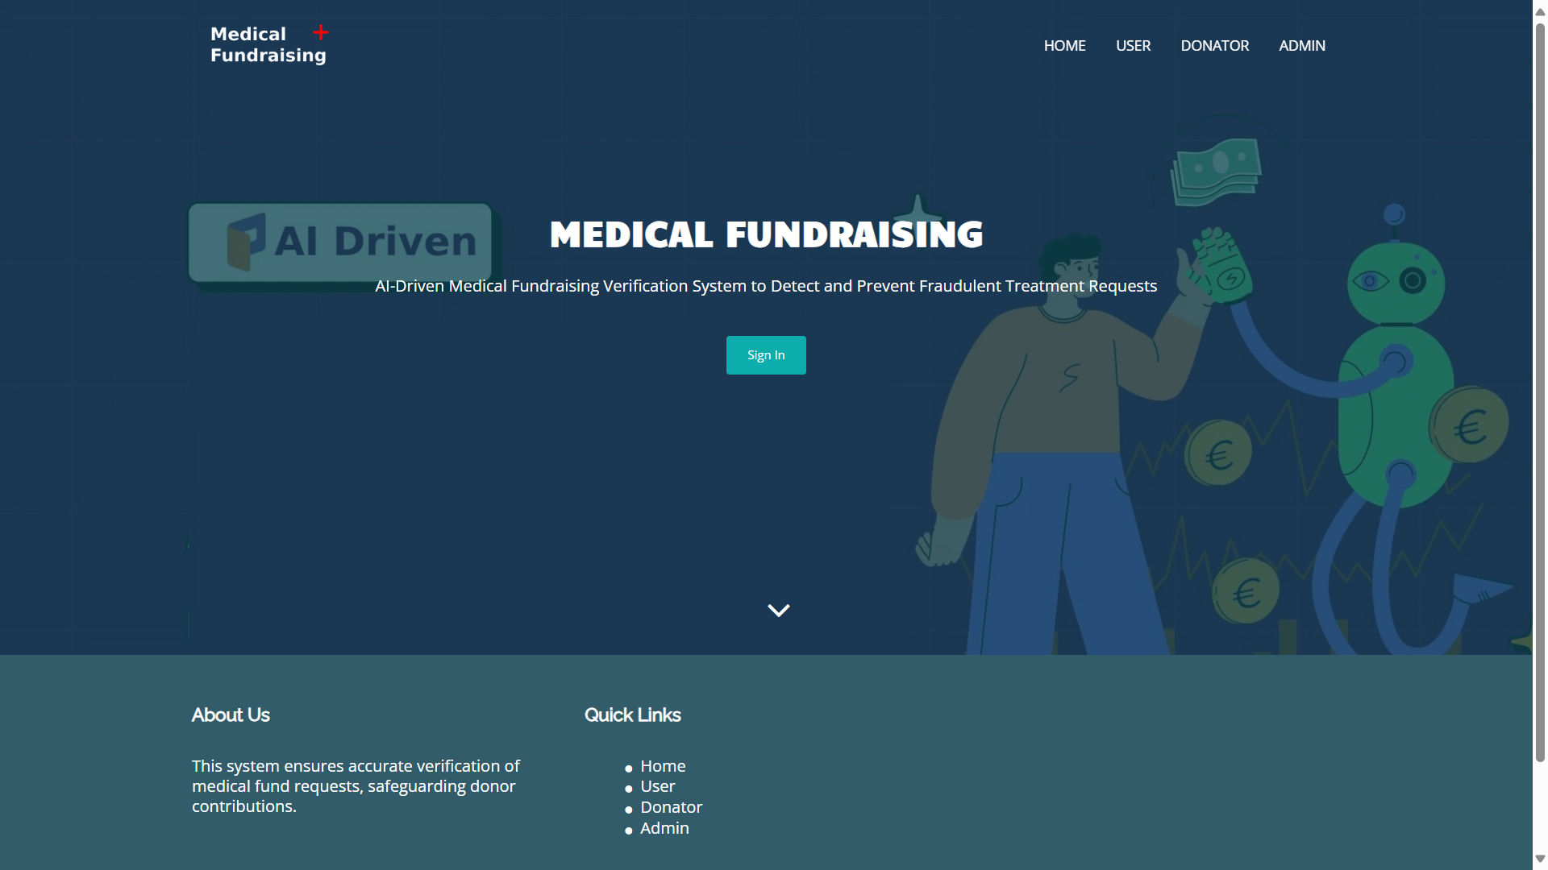

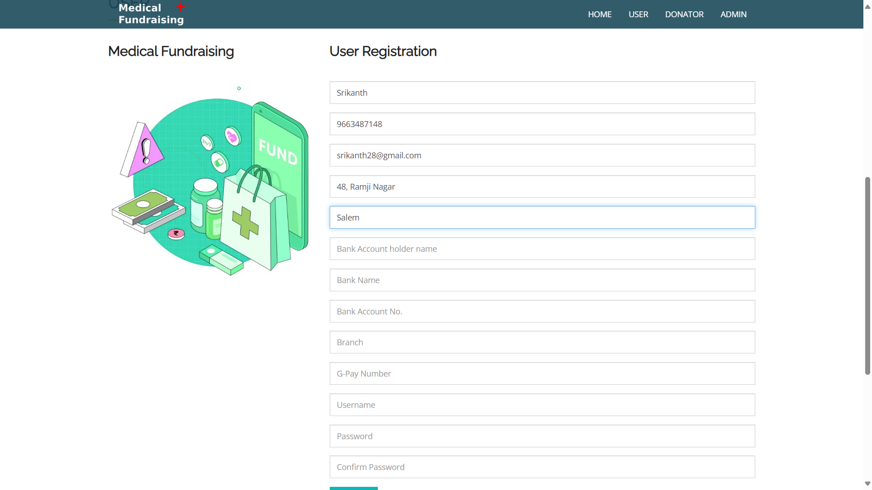

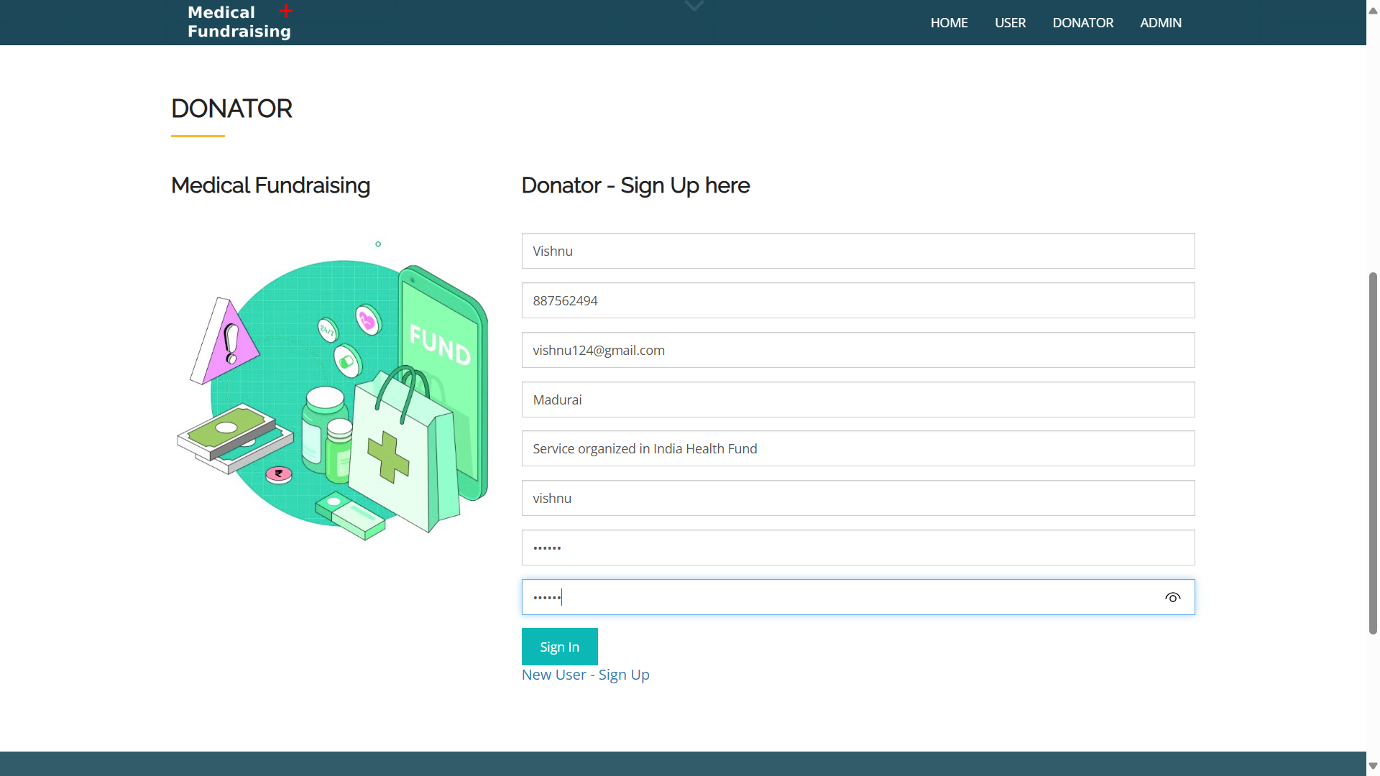

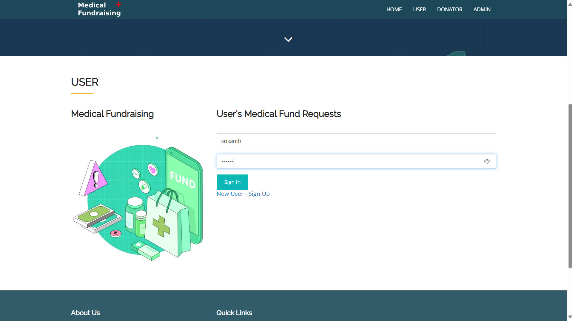

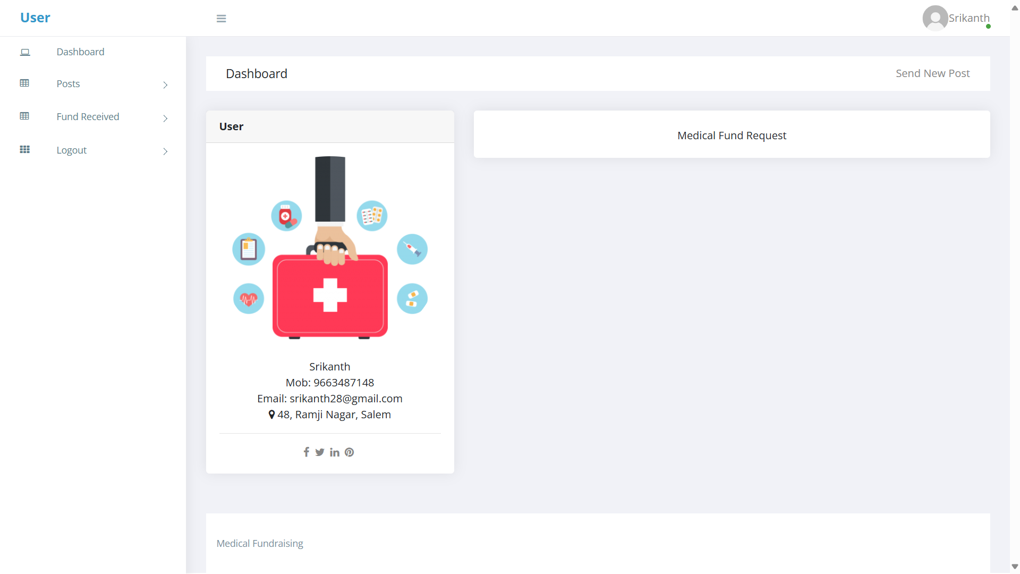

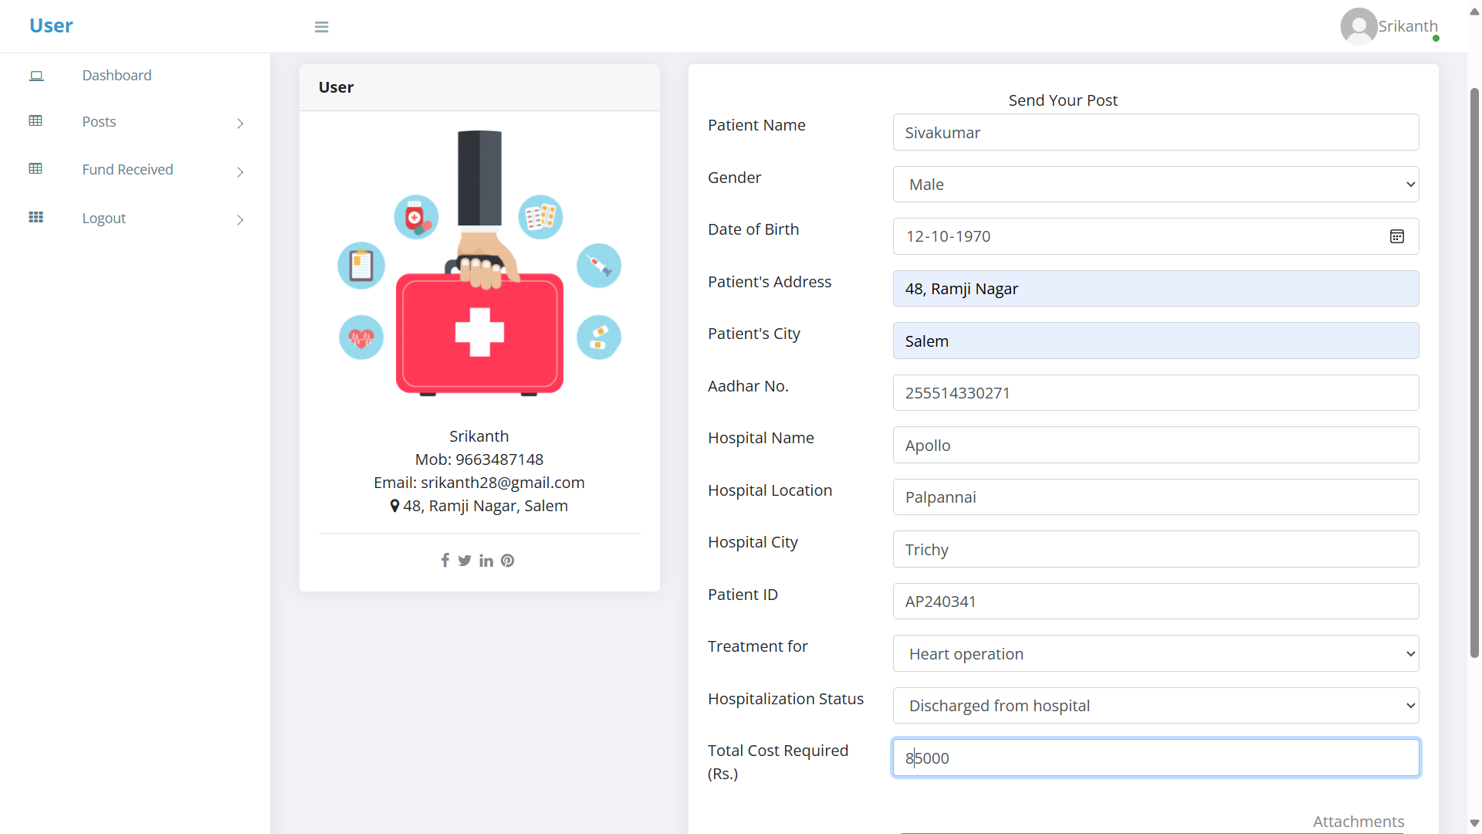

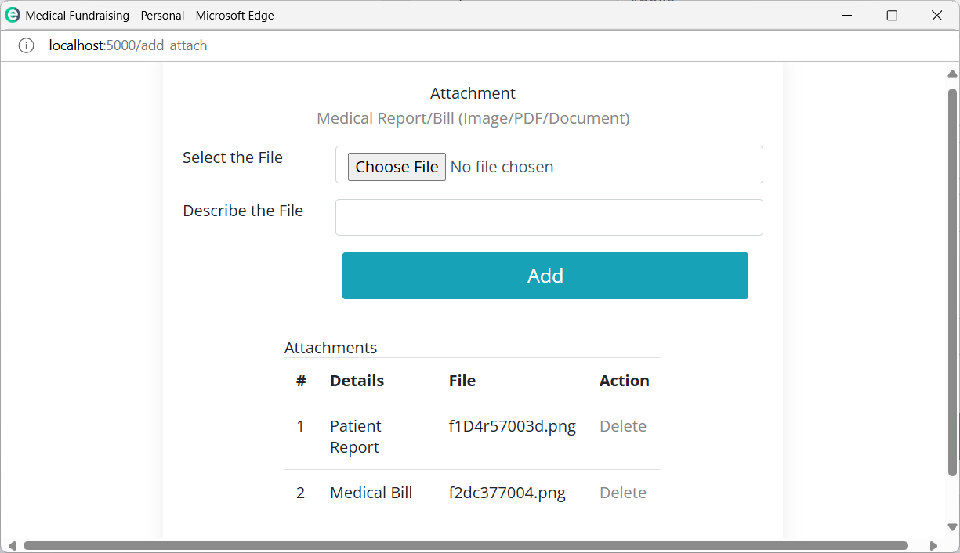

**CHAPTER 8**

**CONCLUSION**

Medical fund fraud is a growing issue where individuals or organizations submit fake, manipulated, or duplicate medical documents to unlawfully claim financial aid. This fraudulent activity results in misuse of resources, financial losses, and delays in assistance for genuine patients in need. Traditional systems for fund distribution often rely on manual verification, which is time-consuming, prone to human error, and lacks real-time fraud detection mechanisms. These existing methods fail to efficiently identify forged documents or repetitive claims, leading to ineffective fund allocation and donor distrust. To overcome these challenges, our project introduces an intelligent, automated Medical Fund Verification System that integrates YOLOv8 object detection, Optical Character Recognition (OCR), machine learning algorithms, and secure payment gateways. The system effectively detects forged bills, manipulated documents, and fake hospital stamps, ensuring that only genuine requests receive funding. Key features include automated fraud detection, a trust score system, a real-time notification module, and a secure donor payment processing system. The project not only enhances accuracy and efficiency in fund verification but also reduces fraud risks and improves transparency in medical fund distribution. With its robust fraud detection capabilities, this system increases donor confidence, ensures fair fund allocation, and streamlines the financial aid process, making it a reliable and impactful solution for combating medical fund fraud.

**CHAPTER 9**

**FUTURE ENHANCEMENT**

* **Blockchain Integration for Security**

Implementing blockchain technology will ensure tamper-proof record-keeping for medical documents and transactions. Smart contracts can automate fund disbursement, ensuring that payments are released only after proper verification, reducing human errors and fraudulent claims.

* **Mobile Application for Accessibility**

Developing a mobile version of the system will allow patients, donors, and administrators to access and manage fund requests from anywhere. Real-time notifications, instant fund verification, and fraud alerts can improve usability and engagement.

* **Integration with Government and Insurance Databases**

To enhance verification accuracy, the system can be integrated with government healthcare schemes and insurance company databases. This will allow real-time validation of medical records and reduce fraudulent claims.

**CHAPTER 10**

**REFERENCES**

**10.1. JOURNAL REFERENCES**

1. Sahu, S., & Nayak, R. (2020). “Medical Fraud Detection using Machine Learning Techniques.” Journal of Healthcare Engineering, 2020. DOI: 10.1155/2020/3281564
2. Koo, D., & Jeong, S. (2020). “Deep Learning for Medical Fraud Detection.” Computers in Biology and Medicine, 123, 103894. DOI: 10.1016/j.compbiomed.2020.103894
3. Redmon, J., Divvala, S., Girshick, R., & Farhadi, A. (2016). “You Only Look Once: Unified, Real-Time Object Detection.” Proceedings of the IEEE Conference on Computer Vision and Pattern Recognition (CVPR), 779-788. DOI: 10.1109/CVPR.2016.91
4. Vijayalakshmi, A., & Rajendran, S. (2019). “Fuzzy Matching Algorithm for Fraudulent Data Detection in Healthcare Systems.” International Journal of Engineering and Advanced Technology, 8(6), 198-203. DOI: 10.35940/ijeat.F8325.088619
5. Deng, Y., & Liu, L. (2021). “PaddleOCR: An Open-Source Optical Character Recognition (OCR) Toolkit.” arXiv preprint arXiv:2104.01932. DOI: 10.48550/arXiv.2104.01932
6. Jha, A., & Verma, S. (2020). “Blockchain-Based Transparent Fundraising for Medical Applications.” Future Generation Computer Systems, 108, 791-800. DOI: 10.1016/j.future.2020.03.001
7. Kshetri, N. (2018). “1 Blockchain and Healthcare Fraud Detection: An Overview.” Computers, Privacy, and Security Issues in Healthcare, 1, 19-34. DOI: 10.1007/978-3-319-77627-1_2
8. Rid, A., & Laskowski, A. (2016). “Ethical Issues in Crowdfunding for Medical Expenses.” JAMA Internal Medicine, 176(5), 681-686. DOI: 10.1001/jamainternmed.2016.1087

**10.2. BOOK REFERENCES**

1. HTML5, CSS3, JavaScript, Bootstrap – Duckett, J. "HTML & CSS: Design and Build Websites", Wiley.
2. Python – Lutz, M. "Learning Python", O'Reilly Media.
3. Flask – Grinberg, M. "Flask Web Development: Developing Web Applications with Python", O'Reilly Media.
4. MySQL – DuBois, P. "MySQL Cookbook", O'Reilly Media.
5. WampServer – Babin, C. "Apache, MySQL, and PHP Web Development All-in-One Desk Reference", Wiley.
6. OpenCV – Kaehler, A., & Bradski, G. "Learning OpenCV 4: Computer Vision with Python", O'Reilly Media.
7. NumPy, Pandas – VanderPlas, J. "Python Data Science Handbook", O'Reilly Media.

**10.3. WEB LINK REFERENCES**

* HTML5, CSS3, JavaScript, Bootstrap – <https://developer.mozilla.org/en-US/docs/Web>
* Python – <https://docs.python.org/3/>
* Flask – https://flask.palletsprojects.com/en/latest/
* MySQL – <https://dev.mysql.com/doc/>
* WampServer – https://www.wampserver.com/en/
* OpenCV – https://docs.opencv.org/master/
* NumPy – https://numpy.org/doc/stable/
* Pandas – https://pandas.pydata.org/docs/